**Queries for KPI’s Requirements**

KPI(Key Performance Indicator)

Query 1: To view the data of the file :

select * from dbo.pizza_sales

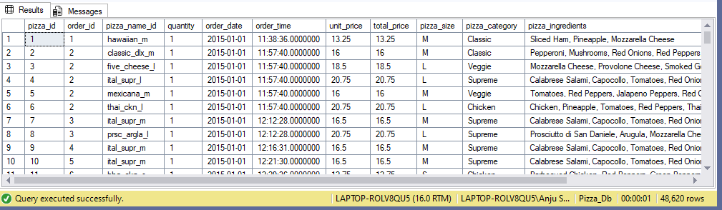

Query 2: To get the total price of all the orders :

select SUM(total_price) as total_revenue from dbo.pizza_sales;

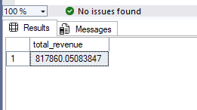

Query 3 : Average order value : Total_revenue/total no. of orders

select SUM(total_price)/COUNT(distinct(order_id)) as average_order_value from dbo.pizza_sales:

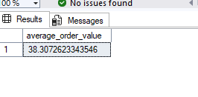

Query 4 : Total Pizza sold :

select sum(quantity) as Total_pizza from dbo.pizza_sales;

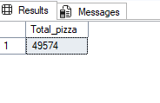

Query 5 : Total number of orders :

select COUNT(distinct(order_id)) as total_orders from dbo.pizza_sales

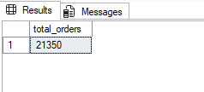

Query 6 : Average pizza sold per order : total number of pizza sold/total number of order :

select SUM(quantity)/count(distinct(order_id)) as average_pizza_sold from dbo.pizza_sales;

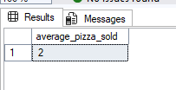

Now as the value cannot be whole number, and SSMS is converting the decimal value to hole number by rounding off, so we will convert this to decimal by using cast function :

select CAST(SUM(quantity) as decimal(10,2))/cast(count(distinct(order_id)) as decimal(10,2)) as average_pizza_sold from dbo.pizza_sales;

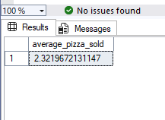

**Chart Requirement Queries**

Query 1: Daily Trend

select datename(dw,order_date) as day, count(distinct order_id) as total_orders from pizza_sales

group by datename(dw,order_date)

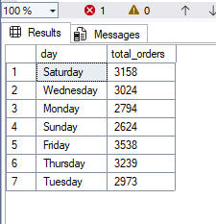

Query 2 : Hourly Trend :

select DATEPART(HOUR, order_time) as Order_hrs, count(distinct order_id) as total_orders from dbo.pizza_sales

group by datepart(hour, order_time)

order by datepart(hour, order_time)

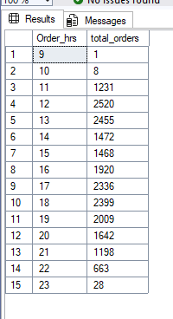

Query 3: Percentage of total sales :

select pizza_category, sum(total_price) *100 / (select sum(total_price) from dbo.pizza_sales) as per_sales

from dbo.pizza_sales group by pizza_category;

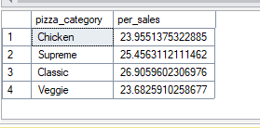

Note : if we want to calculate the sales for month (eg : January, below is the query :

select pizza_category, sum(total_price) *100 / (select sum(total_price) from dbo.pizza_sales where MONTH(order_date) = 1

) as per_sales

from dbo.pizza_sales

where MONTH(order_date) = 1

group by pizza_category;

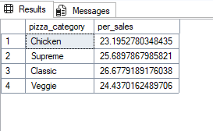

Query 4 : percentage of sales by pizza size :

select pizza_size, sum(total_price) *100 / (select sum(total_price) from dbo.pizza_sales ) as per_sales

from dbo.pizza_sales

group by pizza_size;

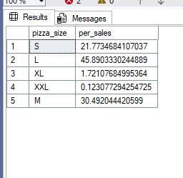

Query 5 : Total pizza sold per pizza catgory :

select pizza_category, sum(quantity) as total_pizza_sold from dbo.pizza_sales

group by pizza_category

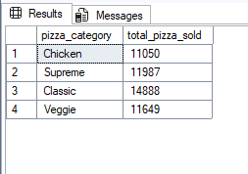

Query 6 : Top 5 pizza sold :

select top 5 pizza_name, sum(quantity) as total_pizza_sold from dbo.pizza_sales

group by pizza_name

order by total_pizza_sold desc;

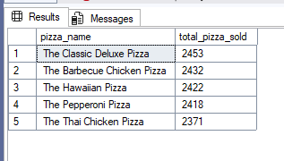

Query 7 : Bottom 5 pizza sold :

select top 5 pizza_name, sum(quantity) as total_pizza_sold from dbo.pizza_sales

group by pizza_name

order by total_pizza_sold

;

